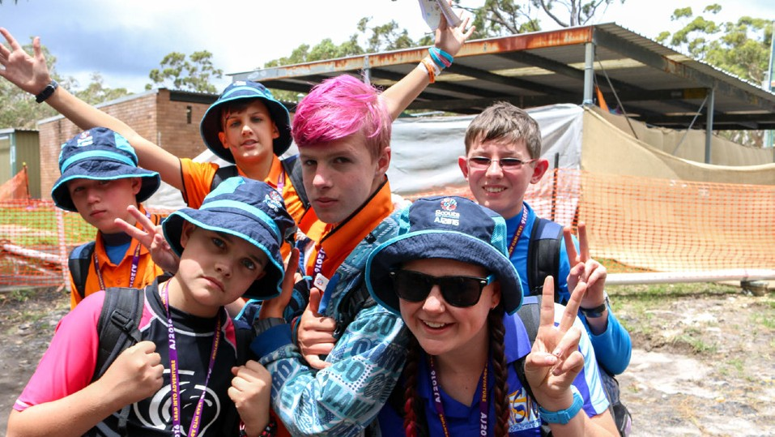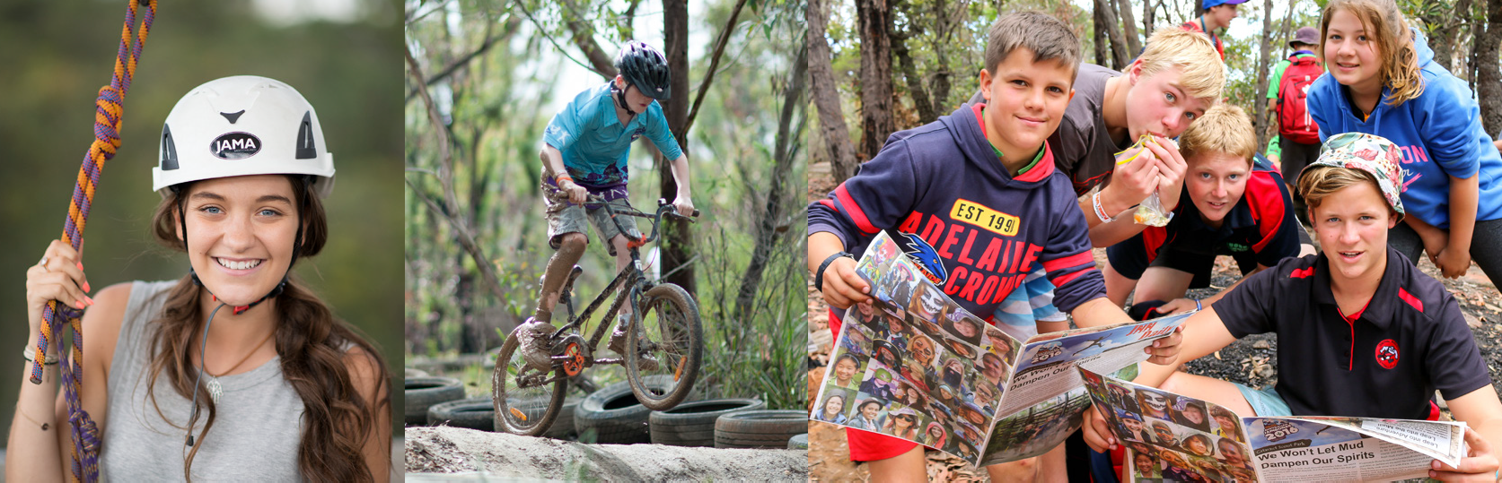

**AJ2025 NSW Contingent Unit Badges**

Your Unit Badge forms a fundamental part of a Unit’s identity at Jamboree. Your **Unit Badge** tells a story to other Units about your identity, the area where you come from and, of course, about the event the badge was created for. Badge swapping creates a lot of excitement and is a big thing for some at Jamboree!

For AJ2025, the NSW Contingent will supply each NSW Unit with 10 badges per participant, with a maximum of 420 badges per Unit in total. Each Jamboree Unit is invited to create their own Unit Badge for AJ2025.

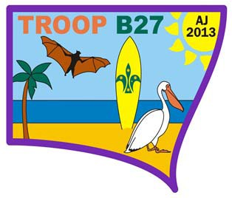

*EXAMPLE:*

*Note*: Not to size

**GUIDELINES AND REQUIREMENTS:**

1. **Identification**

Your Unit badge design is to include:

* Words ‘AJ2025’
* Scout NSW Logo
* Your Jamboree unit number

1. **Colours (or threads)**

The NSW Unit badges can have up to ***nine*** colours.

1. **Badge Design**

Please take care when designing your badge. Do not use licensed images, badge designs will be checked for copyright images and slogans, and for profanities.

1. **Badge Shape**

Your Unit badge design will be reviewed and approved by NSW Contingent. The design of the NSW Contingent unit badges is to fit on a stylised shape of NSW. Attached is a template of the AJ2025 NSW Contingent badge shape.

1. **Badge Dimensions**:

The final AJ2025 NSW Contingent badge will measure95mm x 75mm

**THINGS TO REMEMBER**

* All badge designs must be sent electronically to [nsw.contingent@nsw.scouts.com.au](mailto:nsw.contingent@nsw.scouts.com.au) No snail-mail please.
* Designs must be received prior to **30th July 2024**
* Badges will be distributed with your Jamboree merchandise/Contingent kit in **November 2024**.
* There is no cost for your Jamboree Unit Badges. The cost is already included in the NSW Contingent Fee.
* All Unit badge orders are to be placed through the NSW Contingent at [nsw.contingent@nsw.scouts.com.au](mailto:nsw.contingent@nsw.scouts.com.au) following the above instructions. Please do not contact the supplier directly.

|  |  |  |
| --- | --- | --- |
| **Jamboree Unit Number:** | |  |
| **Jamboree Unit Leader Name:** | |  |
| **Contact Number:** | |  |
| **Colours:** | | **Item/Location:** |
| **1.** |  |  |
| **2.** |  |  |
| **3.** |  |  |
| **4.** |  |  |
| **5.** |  |  |
| **6.** |  |  |
| **7.** |  |  |
| **8.** |  |  |
| **9.** |  |  |



